

**Business Analysis**

**Project Name: Easy Car Rental**

**Submitted By**

**Sweety J.R.Patil**

Business Analyst Training Institute

Dombivli (east)

Weekday’s batch

|  |  |
| --- | --- |
| **Guided By**  **Mr. Omkar Pathak**  Chief Executive officer  Business Analyst Training Institute  Dombivli (east) | **Reviewed by**  **Mr. Omkar Pathak**  Instructor  Business Analyst Training Institute  Dombivli (east) |

INDEX

Contents

Introduction 5

1.1 Introduction of IT companies 5

1.1.1 Product- Based IT Company 5

1.1.2 Service- Based IT Company 5

1.1.3 Project Types in IT Company 5

1.2 Department of IT Company 7

1.2.1 Business / Management team 7

1.2.2 Marketing team/ Sales/ Pre-sales 7

1.2.3 Account/ Finance 8

1.2.4 System / Network 8

1.2.5 Project Management 8

SDLC (Software Development Life Cycle) 9

1. Project initiation phase 11

2. Planning 11

3. Requirement gathering 12

i. High Level Requirement Gathering 14

ii. Low Level Requirement Gathering 15

4. Development 17

5. Testing 17

i. Test Case Document 19

6. UAT (User Acceptance Testing) 20

7. Go-Live/ Production Deployment 21

8. Maintenance and Support 21

Software Development Life Cycle Methodologies 22

i. Waterfall 22

ii. Agile Scrum 23

Diagrams 25

i. Behavioural diagram 25

ii. Structural Diagram 25

1. Flow chart 26

2. Activity Diagram 31

3. Use case Diagram 33

4. Sequence Diagram 34

5. DFD 35

6. Class Diagram 36

7. E-R Diagram 36

6.1 Conceptual 36

i. Find entities & Attributes 36

6.2 Logical 36

i. Define relation between entities 36

ii. Draw entity relationship (ECR) Diagram 36

CHANGE REQUEST FORM 38

MINUTES OF MEETING 39

BRD (Business Requirement Document) 40

Problem Statement 41

Project scope (Goal of Project) 42

As-Is (Existing) Business Process 43

UML Diagram on High level (Flowchart) 43

UML Diagram on High level (Activity) 44

To-Be (Solution /End Product) Business Process 45

UML Diagram on High level (Flowchart) 45

UML Diagram on High level (Activity) 46

Functional Requirements 47

UI screens 47

Non-Functional Requirements 50

1. UI/UX Requirement 50

2. Static Data 50

3. Hardware Configuration 50

4. Software & Database license 50

5. Network Requirement 50

6. Hosting Requirement 50

7. Security Requirement 50

8. Performance Requirement 50

9. Third Party Integration 50

Assumption & Constraints 51

Assumption: 51

Constraints: 51

SRS (Software Requirement Specification) 52

Problem statement 53

Project scope 54

As-is (Existing) Business Process 55

UML Diagram on Low level (Flowchart) 55

UML Diagram on Low level (Activity) 56

To-be (Solution/End product) Business Process 57

UML Diagram on Low level (Flowchart) 57

UML Diagram on Low level (Activity) 58

Functional Specification 59

Use Case Specification 1 59

Use Case Specification 2 60

Use Case Specification 3 61

Use Case Specification 4………………………………………………………………………………………………………………………………… 62

# Introduction

Business analyst is a person who helps to analyzes, summarizes and furnish solution to business requirements of an organizations and interprets the information based on various technologies and business processes by optimizing the overall cost.

## Introduction of IT companies

IT companies are nothing but a company that gives an IT (Information Technology) Solution like developing mobile application, software, websites and web application and provides service, maintenance and support to the client company or customers as their business need.

### Product- Based IT Company

Product based IT Companies are making their own products for their own business and customers, it’s based on B2C model, which is Business to Customer. And they make changes and updates according to their user’s review. Example of Product based IT Companies Amazon, Adobe, Google, Facebook, Microsoft etc.

### Service- Based IT Company

Service based IT Companies are those who develop a Software, apps, web site and web application according to their client requirements. Basically, in service-based companies, IT Company makes particular product for their clients and gives them services like maintenance and support. It’s based on B2B model, which is Business to Business. Few Services based companies TCS, Infosys, Wipro, Tech Mahindra etc.

### Project Types in IT Company

* **Application Development**
* Software development
* Mobile app development
* Website & web application development
* **Customization**
* Add new features
* Remove existing features
* Change existing features
* **Service**
* Maintenance & Support (AMC)
* Development (Application [Development + Customization])
* Testing
* Consulting
* Migration /Transition

1)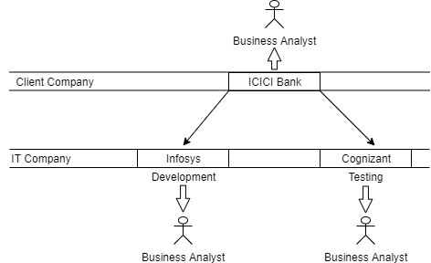2)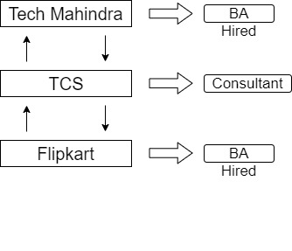

|  |  |
| --- | --- |
| ICICI bank wants to develop app for them, so they give contract to Infosys, and after developing the app, ICICI wants extra accuracy in their app so they refuse to take testing service from Infosys and hire cognizant for testing. | Flipkart wants to develop app for them but they don’t have any knowledge about it, so they will take help from consultancy (TCS), then TCS will consult to Flipkart and suggest them Tech Mahindra for their application development. |
| During that period only BA (Client, IT) is a person who interact with each other for any purpose like requirement gathering, arranging meetings, preparing related documents. | |

## Department of IT Company

* Business team/ Management team
* Marketing team/ Sales/ Pre-sales
* Account / Finance
* System / Network
* Project Management

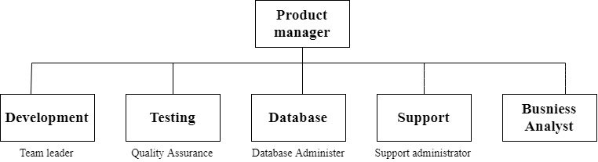

IT companies have these departments, for different type of work according to this

### Business / Management team

Business/ Management team are a group of peoples who manage the things like company’s operations, giving strategic decision for business, monitor all departments, adding a new staff according to company’s need.

### Marketing team/ Sales/ Pre-sales

Marketing team doing marketing and promoting their company’s product, they reaching to the related customers by any way as possible like digital marketing, tendering, offline marketing, phone calls etc. and Sales team responsible to sell their companies product to customers/clients. They have target for it

### Account/ Finance

In that department, they maintain all transaction records, money activities like Cash, Turnover and Profit received through business. And also maintain previous and upcoming transactions records.

### System / Network

Designing and implementing both the physical and wireless networks, including those for computer communications and telecommunications. Maintaining network performance. Managing the electronic equipment that activates any network pieces. Troubleshooting network problems.

### Project Management

IT project managers are responsible for planning, organizing, allocating resources for, budgeting, and successfully executing organizations' specific IT goals. Such projects might include: Software and app development.

**SDLC (Software Development Life Cycle)**

* **Initiation**
* **Planning**
* **Requirement gathering**
* 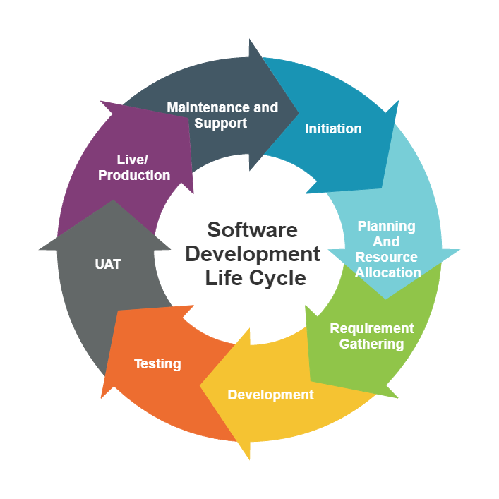**Development**
* **Testing**
* **UAT**
* **Live/Production**
* **Maintenance & support**

Example Scenario, ABC tech is an IT company and ECR (Easy Car Rental) is a client company, and they want to develop application for their business.

|  |  |
| --- | --- |
| ABC Tech  (IT Company) | ECR  (Client company) |
| * Sales | * Business/ Management |
|  | * Marketing |
|  | * Accounts |
|  | * Customer support/Reception |
|  | * Drivers |
|  | * Maintenance |

The sales team of ABC tech and business team of ECR will held meeting before project starts.

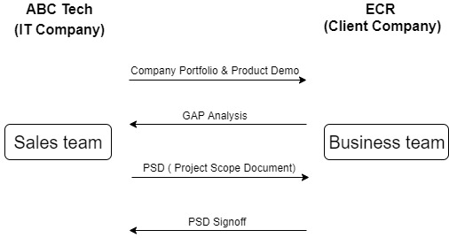

* **Gap Analysis**

|  |  |  |
| --- | --- | --- |
| **Product Feature** | **Client will convey** | **Understand client's existing business** |
| **A** | **P** | **L** |
| **B** | **Q** | **M** |
| **C** | **R** | **N** |
| **D** | **S** | **O** |
| **E** | **T** |  |

## Project initiation phase

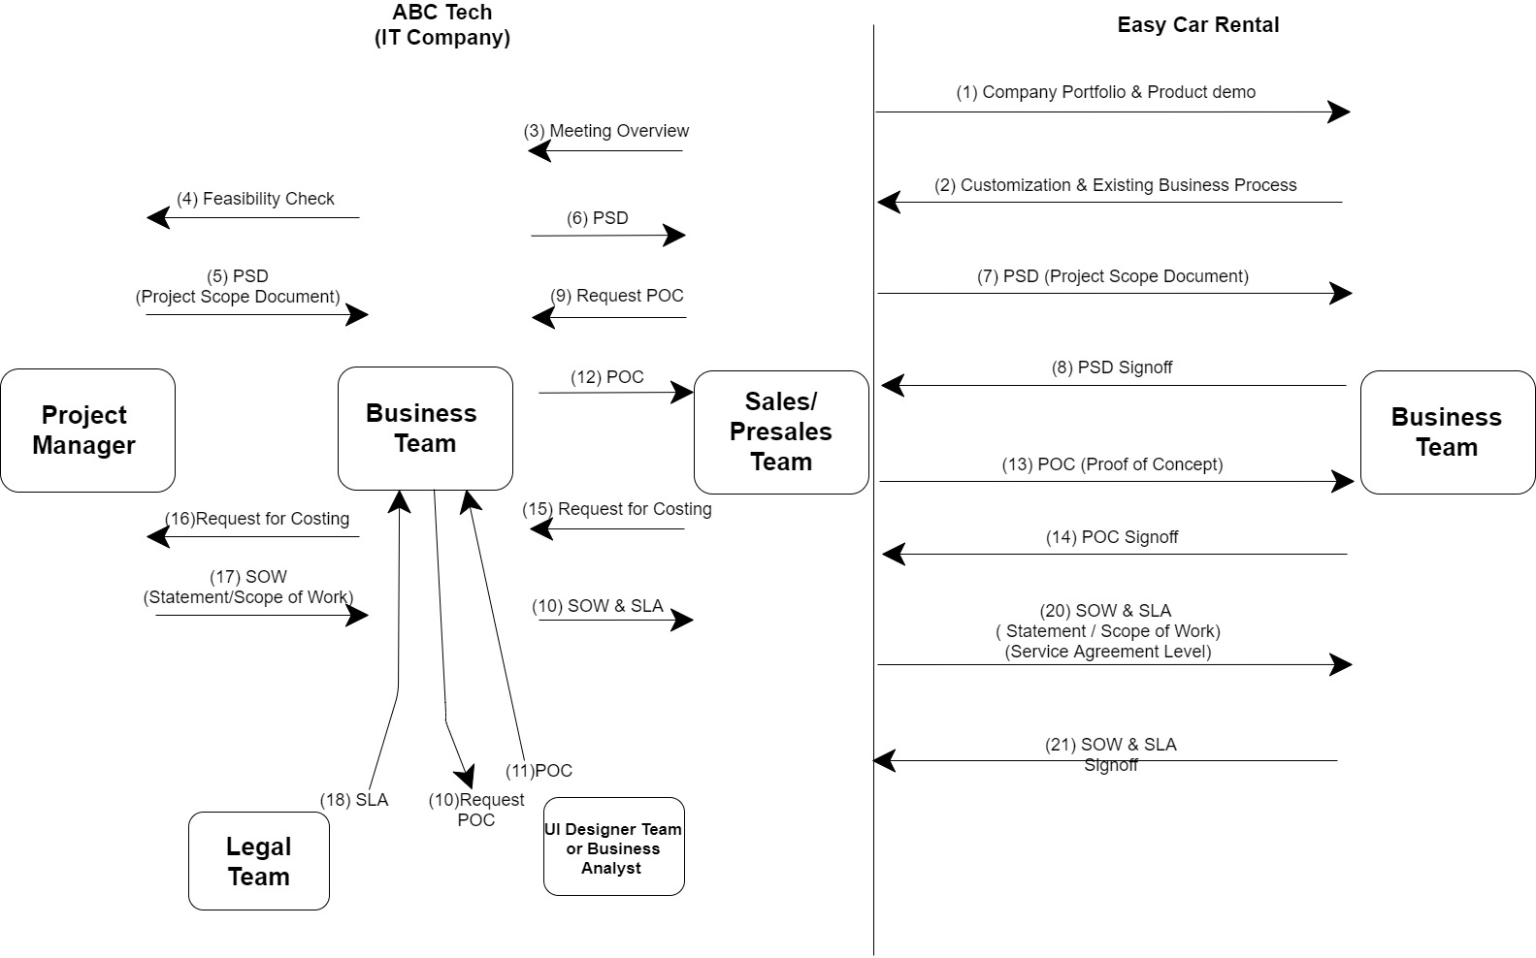

**1. Project initiation** is the first step in starting a new project. During the project initiation phase, you establish why you’re doing the project and what business value it will deliver then use that information to secure buy-in from key stakeholders.

## Planning

In planning phase there will be a task assigning to resource. Setting priorities of project.

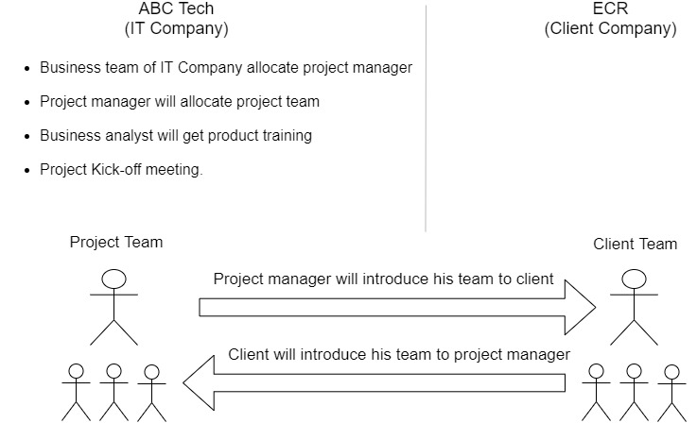

In project kickoff meeting, project manager will introduce his team to client, and client will introduce his team to project manager.

After the planning phase, there will start requirements gathering

## Requirement gathering

* Business Analyst will gather requirement from client through on phone call or by going to client’s location.
* Initially BA will do **High level** requirement gathering, that means happy flow or don’t have negative scenario in it then he goes to **Low level** requirement gathering, in Low level requirement gathering negative scenario will also be consider.
* Then he understands Clients existing business that is called **as-is** Business process. Then the solution will be discussed that is called To-be business process. Both processes will do in High level and low-level requirement gathering.

|  |  |  |
| --- | --- | --- |
|  | Client’s existing business  (**AS-IS** Business process)  Current state | Solution application to be developed  (**TO-BE** Business process)  Future state |
| High Level Requirement Gathering | (1)  High level As-Is   |  |  |  |  |  | | --- | --- | --- | --- | --- | | A | B | C | D | E | | (2)  High level To-Be   |  |  |  |  |  | | --- | --- | --- | --- | --- | | P | Q | R | S | T | |
| Low Level Requirement Gathering | |  |  |  |  |  | | --- | --- | --- | --- | --- | | SME  A | SME  B | SME  C | …… |  |     (3)  Low level As-Is | |  |  |  |  |  | | --- | --- | --- | --- | --- | | P1 | Q1 | R1 |  |  | | P2 | Q2 | R2 |  |  | | P3 | Q3 | R3 |  |  | | P4 | Q4 | R4 |  |  |   (4)  Low level To-Be |

* BA will prepare BRD (Business Requirement Document) /HLD (High Level Document) in high level requirement gathering for As-is and To-be Business process.
* BA will prepare SRS/FS/FRS/UCS/LLD/TD/FRD/FD in low level requirement gathering for As-is and To-be Business process.

i. **High Level Requirement Gathering**

|  |  |  |  |  |
| --- | --- | --- | --- | --- |
| **BRD/ HLD** | Business Requirement on high level. Clients existing business  (As-Is Business process) |  | **IT Business Analysis** | **Client Business Team** |
| 1 | Arrange Meeting with Clients business team as per RACI Matrix to discuss Clients Existing Business process on high.  (Main Business Process / Happy Flow / High level Business Process) |  |
| 2 |  | Attend Meeting |
| 3 | Send Minutes of Meeting |  |
| 4 |  | Approve/Rectify Minutes of Meeting |
| 5 | Send Diagram of High-Level Existing Business Process |  |
| 6 |  | Approve/Rectify Diagram |
| Technical Requirement on high level. Solution To-Be developed by IT company  (To-Be Business process) | 7 | Arrange Meeting to Discuss High Level Flow of solution/ Happy Flow |  |
| 8 |  | Attend Meeting |
| 9 | Send Minutes of Meeting |  |
| 10 |  | Approve/ Rectify Minutes of Meeting |
| 11 | Send Diagram of High-Level Flow of Solution / Happy Flow |  |
| 12 |  | Approve/Rectify Diagram |
| 13 | Prepare UI Screens/ Prototypes on High Level |  |
| 14 |  | Approve/Rectify  UI Screen |
| 15 | Send BRD/HLD |  |
| 16 |  | BRD/ HLD Signoff |

**BRD: Business/ Requirement Document**

**HLD: High level Documents**

### ii. Low Level Requirement Gathering

|  |  |  |  |  |
| --- | --- | --- | --- | --- |
| **SRS/FS/FRS/UCS/LLD/TD/FRD/FD** | Business Requirement on Low level/ Detail Level/ Department level. Clients existing business  (As-Is Business process) |  | **IT Business Analysis** | **Client Business Team** |
| 1 | Arrange Meeting with SMEs of Clients as per RACI Matrix to discuss Client’s Existing Business process on Low Level/ Detail Level/ Department Level |  |
| 2 |  | Attend Meeting |
| 3 | Send Minutes of Meeting |  |
| 4 |  | Approve/Rectify Minutes of Meeting |
| 5 | Send Diagram of Low Level/ Detail Level/ Department Level Existing Business Process. |  |
| 6 |  | Approve/Rectify Diagram |
| Technical Requirement on Low level/ Detail Level/ Department level. Solution To-Be developed by IT company  (To-Be Business process) | 7 | Arrange Meeting to Discuss Low Level/ Detail Level/ Department Level Flow of solution/ Happy Flow |  |
| 8 |  | Attend Meeting |
| 9 | Send Minutes of Meeting |  |
| 10 |  | Approve/ Rectify Minutes of Meeting |
| 11 | Send Diagram of Low Level/ Detail Level/ Department Level Flow of Solution / Happy Flow |  |
| 12 |  | Approve/Rectify Diagram |
| 13 | Send Technical Document **(**SRS/FS/FRS/UCS/LLD/TD/FRD/FD) |  |
| 14 |  | Technical Document Signoff |

**SRS :** Software Requirement Specifications

**FS :** Functional Specifications

**FRS :** Functional Requirement Specifications

**UCS :** Use Case Specifications

**LLD :** Low Level Document

**TD :** Technical Document

**FRD :** Functional Requirement Document

**FD :** Functional Document

**RACI MATRIX:**

|  |  |  |  |  |  |  |  |
| --- | --- | --- | --- | --- | --- | --- | --- |
| **Sr.**  **No.** | **Department**  **Name** | **POC** | **Designation** | **Mobile**  **No.** | **Email** | **Time**  **Zone** | **RACI** |
| **1.** | Business | Peter | Head | 9812345678 | abc@gmail.com | AST | R |
| **2.** | Business | John | Head | 9712345678 | def@gmail.com | EST | A |
| **3.** | Business | Mark | Sr. Associate | 9512345678 | pqr@gmail.com | CST | C |
| **4.** | Business  Operation | Lady | Sr. Associate | 9612345678 | xyz@gmail.com | MST | I |

**R** Responsible (POC who is responsible to give requirement)

**A** Accountable (POC who approve / sign off requirement)

**C**  Consultable (POC to whom team should consult)

**I** Informed (POC who is getting impacted)

* It is a Status of specific Stake Holder.
* Stake Holder: Directly / Indirectly Involve Person in Project
* BA chooses the RACI MATRIX according to the Client.

SRS REVIEW MEETING:

1. BA will get the missing requirement through client and give it to the

technical team.

1. BA will solve the queries of client.

## Development

* Development is a phase where developers start developing product (App/ Web application/ software) with collected requirements from client through Business Analyst.
* They divide the parts of product with each other’s according to their previous project experience or expertise to deliver more accurate product.
* Developers test the program lines and if they find bug then they correct it that is called White box testing.
* After completing task team members will give it to team leader and team leader upload it to Development server.
* **BA Role in Development**
* BA will be engaged in preparing or reviewing test case document.

## Testing

* Testing is a phase where testers start testing the product in separate parts which received from development server.
* Testing done by testing team that is called as Functional Testing, Integration Testing and Black Box Testing.
* When the testing team finds any bug then they categorize it into High, Medium, Low priority then they send it to developers, then developers resolve it.
* Testing team will give sign off after
* **BA Role in Development**
* Testing team or Business analyst prepare test case document. IF testing team prepares it then BA will test it and gives approval
* BA will be engaged parallelly in testing and give final sign-off, then he gives User manual to client.
* BA will be engaged in UAT deployment process.

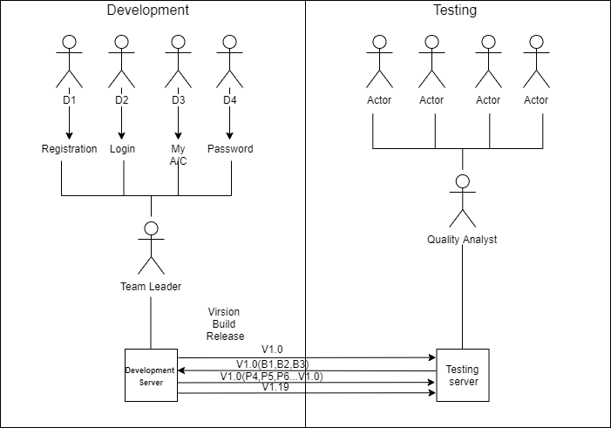

## Test Case Document

|  |  |  |  |
| --- | --- | --- | --- |
| Project Name | Easy Car Rental |  |  |
| Module Name | Login |  |  |
| Test Cases Created on | 27-02-2020 | Test Cases Created by | Dinesh Raghuwanshi |
| Test Cases Updated on | 03-03-2020 | Test Cases Updated by | Ninad Patil |
| Test Cases Reviewed on | 04-03-2020 | Test Cases Reviewed by | Omkar Phatak |
| Test Cases Executed on | 05-03-2020 | Test Cases Executed by | Ninad Patil |

|  |  |  |  |
| --- | --- | --- | --- |
| UAT (Date) | | Production  (Date) | |
| Test  Case  ID # | Test  Cases | Pre-  Conditions | Test  Steps | Expected  Results | Actual  Result | Status  PASS  /  FAIL | Associated  Defects  # | Actual  Result | Status  PASS /  FAIL | Actual  Result | Status  PASS /  FAIL |
| Tc001 | Test if user  is able to  Login  Successfully | User must  be  registered  already | 1.  Enter  Username  And  Password  On  Respective  Field.  2.  Click on  the OK /  Login  Button | 1.  User must  Successfully  Login to  Web  Application.    2.  Username &  Profile  Picture will  be shown  on top  right corner  of Home  Screen. | Same  As  Expected | PASS | NA | Same as  Expected | PASS | Same  as  Expected | PASS |

## UAT (User Acceptance Testing)

In UAT client users do the testing of application, and they find a defect in it.

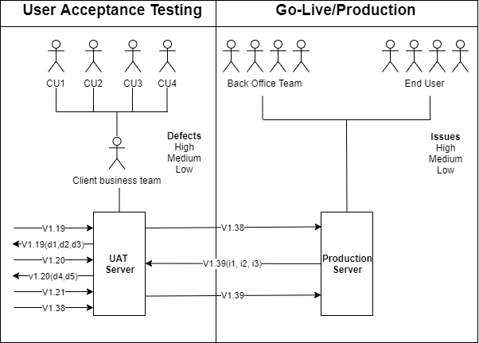

|  |  |
| --- | --- |
| ABC Tech (IT Company) | Easy Car Rental (Client) |
| |  |  |  |  |  | | --- | --- | --- | --- | --- | | **UAT Support Team**   |  |  |  | | --- | --- | --- | | S1 | S2 | S3 |   Support team will resolve defect and test it.  3 | **Business Analyst**   * In case of defect, Business analyst will be defined priorities of defect with client 2 * Business analyst will give final confirmation on resolution and engaged in UAT deployment.4 * Business analyst with project team and client POCs will be engaged in live / Go live deployment 6 | | |  |  |  | | --- | --- | --- | | Client Team member 1 | Client  SME | Client Team member 1 |     1 Client will start testing  application  5 Client will give UAT signoff |

## Go-Live/ Production Deployment

|  |  |
| --- | --- |
| ABC Tech (IT Company) | Easy Car Rental (Client) |
| |  |  |  |  |  | | --- | --- | --- | --- | --- | | **Production**  **Support**  **Team**   |  |  |  | | --- | --- | --- | | S1 | S2 | S3 |   Support team will resolve Issue and test it.  3 | **Business Analyst**   * In case of issue, Business analyst will be defined priorities of issue with client 2 * Business analyst will give final confirmation on Issue Resolve.   4 | | |  |  |  | | --- | --- | --- | | Client Team member 1 | Client  SME | Client Team member 1 |     1 Client will start testing  application  5 Client will give Final signoff |

## Maintenance and Support

|  |  |
| --- | --- |
| Business Analyst (IT Company) | Easy Car Rental (Client) |
| * As per AMC (Annual Maintenance Contract) BA will take new requirement /changes/ enhancement or resolve issue. * Feasibility check & costing will be done & BA will send CR (Change Request/Change Requirement) * Client will approve CR form * Phase from development to live will be repeated |  |

# Software Development Life Cycle Methodologies

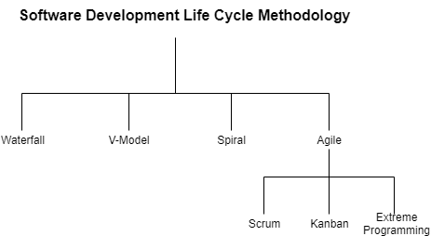

## Waterfall

* Waterfall method is also called as sequential and traditional method, it has top to bottom flow.
* In this method we cannot go back to previous phase.
* Waterfall method only applies on project which have clear requirement, [client well known with existing project].

|  |  |
| --- | --- |
| Advantages | Disadvantages |
| 1. Time & Cost is fixed 2. Product quality is better 3. Documentation is very much detailed. | 1. Time of delivery will be extended 2. No change will be done after taking waterfall method 3. Client can’t see project process until UAT phase. |

## Agile Scrum

* Agile is applicable on project where requirement is unclear.
* This method mostly used in complicated projects.
* Client will decide user stories.
* Agile is also called as Incremental delivery.
* IT Company take requirement of next sprint.
* Client Company gives requirement of next sprint.
* **Sprint:** A sprint is a short, time-boxed period required to complete a list of tasks in a particular sprint backlog to deliver an increment. The sprint period ranges from 2-4 weeks with most common period begin of 2 weeks.
* **Product Backlog:** It is the ordered list of requirements (in the form of user stories) that must be executed to deliver a viable product. The list may include features, requirements and enhancements and fixes that acts as an input for the sprit backlog. The product backlog is maintained by the Product Owner who checks the feasibility of requirements prioritizes them and stores them in orderly manner in product backlog.
* **Sprint Backlog:** Sprint backlog is the list of tasks, items or user stories selected by the scrum team to be completed during a particular sprint.
* **Sprint Planning Meeting :** At the beginning of a sprint, the scrum team does Sprint Planning Meeting to:

**a]** Mutually discuss and agree on the scope of the work that needs to be done during the sprint.

**b]** Select product backlog items that can be completed in one sprint.

**c]** Prepare a sprit backlog that includes the selected product backlog items to be delivered.

**d]** Decide sprint goal, as to what they going to deliver at the end of the sprint.

At the end of the planning meeting, every scrum member is clear on what can be delivered in the sprint and how the increment can be delivered.

* **Daily Scrum:** It is a 15-mint time-boxed stand up meeting in which scrum team and client discuss about the completed task, tasks which are going to complete and any obstacles coming in achieving the upcoming tasks.
* **Sprint Review:** At the end of each sprint, a sprint review meeting is held between the scrum team and client to show what is accomplished during the particular sprint.

**a]** In review meeting the team shows the completed tasks and the task which is not completed.

**b]** Present the completed task to the stakeholders by giving demo.

**c]** Collaborates with stakeholders on what to work on next.

* **Sprint Retrospective:** In this meeting (facilitated by Scrum Master) is held by Scrum Team to inspect itself and create a plan for improvements to be enacted during the next sprint. The sprint retrospective occurs after the Sprint Review and prior to the next Sprint Planning.
* **Story Point:** Story points are units of measurement used to determine how much effort is required to complete a product backlog item or any other piece of work. The team assigns story points based on the work's complexity, amount, and uncertainty.
* **Poker Planning:** Before anyone gets too excited and starts buying poker chips, we should explain that this isn’t normal Poker, per se. Yes, it involves cards (unless you use the app version), indeed it is a tool used to aid agile teams in estimating and planning. You won’t find many royal flushes here. Planning Poker, also called “Scrum Poker,” is a consensus-based agile planning and[estimating](https://www.simplilearn.com/agile-and-scrum/agile-and-scrum-certification-training) technique used to assess product[backlogs](https://www.simplilearn.com/estimation-tools-and-techniques-part-i-article), guessing how much time and effort is needed to complete each of the backlog’s initiatives. It’s called “Poker” because everyone uses physical cards that resemble playing cards. The cards estimate the number of story points for each task or[backlog](https://www.simplilearn.com/what-is-sprint-backlog-article) story being discussed. This Poker tool cards are assigned numerical values loosely based on the Fibonacci sequence, where each successive number in a numerical sequence is the sum of the previous two numbers (e.g., 0, 1, 1, 2, 3, 5, 8, 13, 21, and 34). However, sometimes the Poker tool uses this sequence: 0, 1, 2, 3, 5, 8, 13, 20, 40, and 100.
* **BA role in scrum:**
* BA will independently hire in that project; experienced BA is product owner also.
* Role of BA in SCRUM project: BA with the product owner will do the requirement gathering from client & convert those into User stories.

1] If a BA is experienced he/she is hired as a product owner. He will collect requirements, create User stories, prepare Product backlogs, prepare Sprint backlog and give product updates to the client and participate in sprint ceremonies.

2] If BA is from technical background he can work as scrum Master, Resolve technical issues queries of Cross functional team monitor them and guide them.

3] He can be hired as independent BA and work along with product owner and Scrum master.

* **Product Owner:** The Product owner is the representative of the product’s stakeholders and the voice of the customer. The product owner defines the product in customer-centric terms (typically user stories), adds them to the Product backlog, and prioritize them based on importance. The product owner role bridges the communication gap between the team and its stakeholders.
* **Scrum Master:** Scrum Master is the team facilitator who is accountable for removing obstacles towards the product goals and deliverables. He acts as a buffer between the team and distracting influence.
* **Development Team:** The Development Team decides how to accomplish the work set forth by the Product Owner and carry out all the tasks required to build a product increment of valuable output in every sprint.
* **Iterative process:** An iterative process is one that makes progress through successive refinement. The development team develops first cut of the system, knowing in advance that some/many parts are incomplete. The team then iteratively enhances those parts until the product is satisfactory. With each iteration, customer’s feedback is taken into account and the software is improved through the addition of greater detail. For example, let us take an example of search functionality on a website. In for iteration, a simplistic search screen can be built. In next iteration, advanced search criteria can be added.
* **Incremental Process:** An incremental process involves delivering components of software in parts. Each increment represents a complete subset of functionality and is fully coded and tested. For example, for an e-commerce store, initially payment can be supported only via credit and debit cards. In the next release, payment via wallets can be supported.

# Diagrams



## Behavioural diagram

* Flow chart
* Activity Diagram
* Use case Diagram
* Sequence Diagram
* DFD

## Structural Diagram

* Class Diagram
* E-R Diagram

## Flow chart

**Notation**

|  |  |  |
| --- | --- | --- |
|  | Flowchart | Activity |
| Start |  |  |
| Stop |  |  |
| Process |  |  |
| Decision |  |  |
| Message or Data Flow |  |  |
| Connector |  |  |

**AS-IS High level**



**To-Be High Level**



**As-Is Low level**



**To-Be Low level**



## Activity Diagram

**As-Is High level**



**To-Be High level**



**As-Is Low level**



**To-be Low level**



## Use case Diagram



|  |
| --- |
| **Notation** |

## Sequence Diagram



## DFD



## Class Diagram

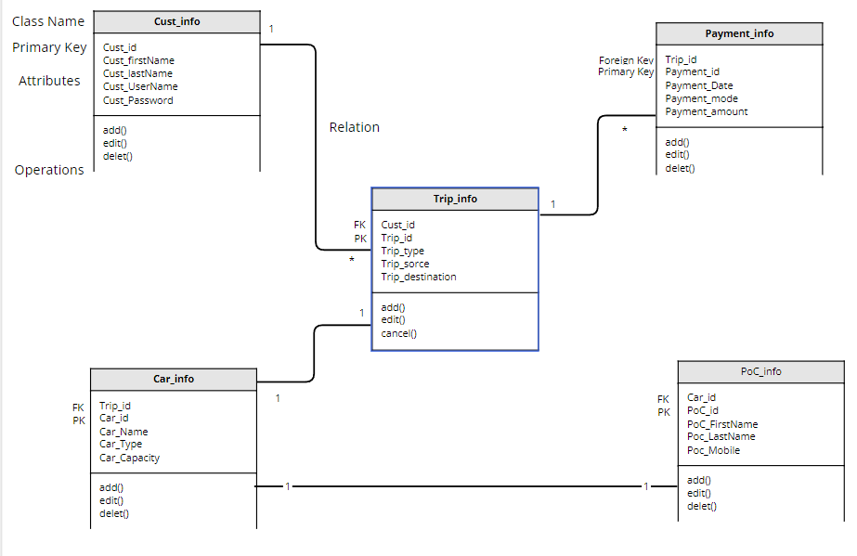

## E-R Diagram



# CHANGE REQUEST FORM

|  |  |  |  |  |  |  |  |
| --- | --- | --- | --- | --- | --- | --- | --- |
| **1) SUBMITTER – GENERAL INFORMATION** | | | | | | | |
| CR# | *[CR001]* | | | | | | |
| Types of CR | Enhancement | | Defects | | |  | |
| Project/Program/Initiative |  | | | | | | |
| Submitter Name | *[John Doe]* | | | | | | |
| Brief Description of Request | *[Enter a detailed description of the change being requested]* | | | | | | |
| Date Submitted | *[mm/dd/yyyy]* | | | | | | |
| Date Required | *[mm/dd/yyyy]* | | | | | | |
| Priority | Low | Medium | | | High | Mandatory | |
| Reason for Change | *[Enter a detailed description of why the change being requested]* | | | | | | |
| Other Artifacts Impacted | *[List Other artifacts affected by this change]* | | | | | | |
| Assumption and Notes | *[Document assumptions or comment regarding the requested change]* | | | | | | |
| Comments | *[Enter additional comments]* | | | | | | |
| Attachments or References | Yes | | | No | | |  |
| Link: | | | | | | |
| Approval Signature | *[Approval Signature]* | | | Date Signed | | | *[mm/dd/yyyy]* |

|  |  |  |  |  |
| --- | --- | --- | --- | --- |
| **2) PROJECT MANAGER – INITIAL ANALYSIS** | | | | |
| Hour Impact | *[#hrs]* | *[Enter the hour impact of the requested change]* | | |
| Duration Impact | *[#dys]* | *[Enter the duration impact of the requested change]* | | |
| Schedule Impact | *[WBS]* | *[Detail the impact this change may have on schedule]* | | |
| Cost Impact | *[Cost]* | *[Detail the impact this change may have on cost]* | | |
| Comments | *[Enter additional comments]* | | | |
| Recommendation | *[Enter recommendation regarding the request change]* | | | |
| Approval Signature | *[Approval Signature]* | | Date Change | *[mm/dd/yyyy]* |

|  |  |  |  |  |  |
| --- | --- | --- | --- | --- | --- |
| **3) CHANGE CONTROL BOARD - DECISION** | | | | | |
| Decision | Approved | Approve with  Conditions | | Rejected | More  Info |
| Decision Date | *[mm/dd/yyyy]* | | | | |
| Decision Explanation | *[Document the CCB’s decision]* | | | | |
| Conditions | *[Document and conditions imposed by CCB]* | | | | |
| Approval Signature | *[Approval Signature]* | | Date Signed | *[dd/mm/yyyy]* | |

# MINUTES OF MEETING

**Date:** Thursday, August 18, 2022.

**Time:** 9:30PM to 11:00 PM IST

**Company Name:** ABC Tech **Client Name:** Easy Car Rental Pvt Ltd XYZ Compound Andheri – 400047

Dombivli – 420101.

**Topic:** Meeting with Easy Car Rental Representatives.

**Attendees:**

|  |  |  |
| --- | --- | --- |
| **Name** | **Designation** | **Present / Absent status** |
| OMKAR PHATAK | M.D. (ECR) | PRESENT |
| SRAJAN PUTHRAN | BUSINESS ANALYST | PRESENT |
| Sweety Patil | BUSINESS ANALYST | PRESENT |
| Siddi Patil | BUSINESS ANALYST | PRESENT |
| Vinita Nemade | BUSINESS ANALYST | PRESENT |

**Meeting Agenda:** To discuss the business requirements of Easy Car Rental Organization.

**Discussion Points:**

AS IS BUSINESS FLOW-

1. Customer have to walk in on nearby Easy Car Rental (ECR) office to booking a car for their trip or where they want to go, then they have to do enquiry on reception, then reception will suggest perfect car for them.
2. If customer satisfy with suggested car and wants to go further towards booking then they have to fill booking form, where ECR mentioned all the policies, and gather all the details of customer like time, date, destination, no. of passengers etc.
3. ECR will accept partial and full payment at a time of booking, so customers have to do according to their preference. After payment ECR gives receipt of payment to customer.
4. Now Driver gets allocated to that trip, ECR informed the customer and driver of their details.
5. On the trip day, driver will pick up the customer from their pickup point.
6. Driver updates trip status.
7. During the trip if customer ask driver to go with their route and it takes more KM than normal so ECR will charge extra.
8. Driver drop customer to their destination. And collect remaining payment, after that receipt will issue to the customer.
9. Reception will update form details and submit collected details with money to account team.
10. The Account Department of ECR will close the booking after receiving total payment through reception.
11. More detail overview of the business will be taken from the SME of the Client.

|  |  |  |  |  |  |  |  |
| --- | --- | --- | --- | --- | --- | --- | --- |
| **SR No.** | **DEPARTMENT** | **POC** | **Email** | **MOBILE NO.** | **RESPONSIBILITY** | **DUE DATE** | **COMMENT** |
| 1 | Booking Department | Omkar Pathak | Omkarpathak21@gmail.com | 9123456780 | Booking Executive | 18/08/2022 | Will be Provided |
| 2 | Help and Support Department | Dinesh Kumar | Kumardinesh12@gmail.com | 9345678912 | Support Executive | 18/08/2022 | Will be Provided |

# BRD (Business Requirement Document)

**Document history:**

|  |  |  |  |  |  |
| --- | --- | --- | --- | --- | --- |
| Version | Prepared by | Prepared date | Reviewed by | Review date | Change Log |
| V 1.0 | Sweety | 05thAug  2022 | Omkar | 05th Aug 2022 | N.A. |
| V 1.1 | Sweety | 20th Aug 2022 | Omkar | 21th Aug 2022 | 3.1,4.1 |
|  |  |  |  |  |  |
|  |  |  |  |  |  |
|  |  |  |  |  |  |
|  |  |  |  |  |  |
|  |  |  |  |  |  |
|  |  |  |  |  |  |
|  |  |  |  |  |  |

## Problem Statement

* Either call booking or physically visit booking.
* For Cab booking Customer need to call ECR or personally need to go ECR’s Office.
* That’s why Customers must have to check ECR's working days and hours.
* Booking Cab at specific time (Office time)
* Customer can only able to book cabs at ECR’s office time.
* If Customer wants immediate cab, then it not possible.
* No transparency between Driver and ECR.
* After allocating driver to trip, ECR don’t have option to track exact trip details.
* ECR must believe on Driver’s given data.
* Sometime drivers cheat with ECR.
* Traditional payment methods
* ECR use only traditional payment method (Cash, Bank transfer) so it takes more effort to maintain all records.
* Sometimes it causes some mistakes in accounts records.
* Needs to maintain all previous records in physical space.
* ECR needs to maintain all previous records in files, it takes large space.
* There is always the possibility that records will be lose.
* Can’t able to take multiple bookings at a time
* By traditional method (Office/Call) ECR can’t able to take multiple bookings at a time.
* Can’t able to take bookings from another city.

## Project scope (Goal of Project)

1. Providing facility to book a ride at anytime from anywhere.
2. Providing multiple payment options.
3. Providing feature to view history rides and receipts.
4. Providing one click receipt downloading feature.
5. Also providing an option to track a ride.
6. In app calling and messaging option also providing.

The goal is to make easy and user-friendly application for booking cab on rent easily for customers need, they don’t need to visit personally to company office etc.

## As-Is (Existing) Business Process

UML Diagram on High level (Flowchart)

This diagram shows what is flow of process of booking a car in **As- is** process or existing business of ECR, what people involved in it, what task they do in whole process. **C is Customer, R is Receptionist, D is Driver, A is Accountant.**

### UML Diagram on High level (Activity)



This diagram shows involved people’s activity like who exactly involved in whole process (**Customer, Receptionist, Driver, Accountant**) what they exactly doing in process of booking a car in As- is or existing business of ECR, how the process is running while this scenario.

## To-Be (Solution /End Product) Business Process

UML Diagram on High level (Flowchart)****

This diagram shows what is flow of process of booking a car in **To-Be** process or existing business of ECR, what people involved in it, what task they do in whole process. **C is Customer, R is Receptionist, D is Driver, and A is Accountant.**

### UML Diagram on High level (Activity)



This diagram shows involved people’s activity like who exactly involved in whole process (**Customer, Receptionist, Driver, Accountant**) what they exactly doing in process of booking a car in **To-be** or existing business of ECR, how the process is running while this scenario.

## Functional Requirements

### UI screens

|  |  |
| --- | --- |
| **1**  **Login-Register page**  Put login details or click on any social media which you want or just register with email. | **2**  **Sign up with email**  Put active email and set password (You will receive verification link) |
| **3**  **Home page**  Start Booking  Select booking type (Immediate / Schedule)  Set pickup and drop location by clicking saved address or putting new address. | **4**  **Pickup and drop location**  Putting up Pickup and drop address.  You can put it manually or select through map also. |
| **5**  **Vehicle type and Payment**  Select vehicle type as your needs, set payment method which you want. | **6**  **Confirmation and cancel**  You can see here confirmation of your trip, able to download or email the reciept of trip from here, you can able to cancel trip from here. |

## Non-Functional Requirements

### UI/UX Requirement

### Static Data

### Hardware Configuration

4 GB ram or more

150 free spaces required.

Location sensors required.

For website, any browser is fine but must have updated version of it.

### Software & Database license

Sql server.

### Network Requirement

Any network is fine with minimum speed of 5mbps.

### Hosting Requirement

Website: https://www.ecr-india.com

### Security Requirement

System must be followed all security laws; all data must be protected in safe servers.

### Performance Requirement

Page opening and changing time should be less as possible, multiple bookings from different locations within the same circle for single car which available nearby them must not cause a server crash or any glitch.

### Third Party Integration

Payment gateway: G-pay, Amazon Pay, Bhim etc.

## Assumption & Constraints

### Assumption:

1. You will be provided multiple options for login / sign-up
2. You will get add edit remove option for address, in profile.
3. You will able to schedule your ride.
4. You will be provided multiple options in cars type and payment.
5. Are also able to cancel ride (T&C)
6. Also, able to track location of current ride.

### Constraints:

1. You must 18+ and register your account for booking rides.
2. You must select exact time of trip.
3. If you want to cancel your trip then you must cancel the ride within 24 hours otherwise it will be chargeable (T&C)
4. You must select available locations.

# SRS (Software Requirement Specification)

**Document history:**

|  |  |  |  |  |  |
| --- | --- | --- | --- | --- | --- |
| Version | Prepared by | Prepared date | Reviewed by | Review date | Change Log |
| V 1.0 | Sweety | 05thAug  2022 | Omkar | 05th Aug 2022 | N.A. |
| V 1.1 | Sweety | 20th Aug 2022 | Omkar | 21th Aug 2022 | 3.1,4.1 |
|  |  |  |  |  |  |
|  |  |  |  |  |  |
|  |  |  |  |  |  |
|  |  |  |  |  |  |
|  |  |  |  |  |  |
|  |  |  |  |  |  |
|  |  |  |  |  |  |

## Problem statement

* Either call booking or physically visit booking.
* For Cab booking Customer need to call ECR or personally need to go ECR’s Office.
* That’s why Customers must have to check ECR's working days and hours.
* Booking Cab at specific time (Office time)
* Customer can only able to book cabs at ECR’s office time.
* If Customer wants immediate cab, then it not possible.
* No transparency between Driver and ECR.
* After allocating driver to trip, ECR don’t have option to track exact trip details.
* ECR must believe on Driver’s given data.
* Sometime drivers cheat with ECR.
* Traditional payment methods
* ECR use only traditional payment method (Cash, Bank transfer) so it takes more effort to maintain all records.
* Sometimes it causes some mistakes in accounts records.
* Needs to maintain all previous records in physical space.
* ECR needs to maintain all previous records in files, it takes large space.
* There is always the possibility that records will be lose.
* Can’t able to take multiple bookings at a time
* By traditional method (Office/Call) ECR can’t able to take multiple bookings at a time.
* Can’t able to take bookings from another city.

## Project scope

1. Providing facility to book a ride at anytime from anywhere.

2. Providing multiple payment options.

3. Providing feature to view history rides and receipts.

4. Providing one click receipt downloading feature.

5. Also providing an option to track a ride.

6. In app calling and messaging option also providing.

The goal is to make easy and user-friendly application for booking cab on rent easily for customers need, they don’t need to visit personally to company office etc.

## As-is (Existing) Business Process

UML Diagram on Low level (Flowchart)

This diagram shows what is flow of process of booking a car in **As- is** process or existing business of ECR, what people involved in it, what task they do in whole process. This is **Low level** diagram and we also consider negative scenario here, **C is Customer, R is Receptionist, D is Driver, A is Accountant.**

### **UML Diagram on Low level (Activity)**



This diagram shows involved people’s activity like who exactly involved in whole process (**Customer, Receptionist, Driver, Accountant**) what they exactly doing in process of booking a car in As- is or existing business of ECR, how the process is running while this scenario, this is **Low level** diagram and we also consider negative scenarios here.

## To-be (Solution/End product) Business Process

### **UML Diagram on Low level (Flowchart)**



This diagram shows what is flow of process of booking a car in **To-be** process or proposed system of ECR, what people involved in it, what task they do in whole process. This is **Low level** diagram and we also consider negative scenario here. **C is Customer, R is Receptionist, D is Driver and A is Accountant.**

### **UML Diagram on Low level (Activity)**



This diagram shows involved things/people’s activity like what and who exactly involved in whole process (**Customer, Application, Driver**) what they exactly doing in process of booking a car in To-be or Proposed system of ECR, how the process is running while this scenario, this is **Low level** diagram and we also consider negative scenarios here.

## 

### Functional Requirement

### Use Case Specification 1

|  |  |  |  |
| --- | --- | --- | --- |
| **Use Case ID:** | **Ucid001** | **Prepared By** | **Sweety** |
|  | | **Prepared Date:** |  |
| **Use Case Name: New User Can Register** | | | |
| **Use Case Diagram:** | | | |
| **Actors: New User** | | | |
| **Pre-Condition** | | | |
| **1.User Must Be 18+** | | | |
| **Successful Post Condition** | | **Unsuccessful Post Condition** | |
| 1. **Show Pop-up window with message**   **“User Registration Successful”**   1. **Click on ‘OK’ Button & navigate to login page** | | 1. **Stay on Registration page** 2. **Show validation message below field name in color ‘Red’ font ‘Arial’ size 10** 3. **Please refer validation message in field validation table** | |
| **Basic Flow** | | **Alternate Flow** | |
| 1. **Click on ‘Register’ link on top right corner of home page** 2. **Fill mandatory fields** 3. **Click on submit button** | | 1. **Click on ‘Register’ link on footer & pre-payment page.** 2. **Fill mandatory fields** 3. **Click on submit button** | |
| **Field Validation Table** | | | |
|  | | | |

|  |  |  |  |  |  |  |  |  |  |  |
| --- | --- | --- | --- | --- | --- | --- | --- | --- | --- | --- |
| **Sr. No** | **Field Name** | **Control Type** | **Data Type** | **Length** | **Default Value** | **Other Value** | **Functional Requirement** | **Business Rule** | **Validation Rule** | **Validation Message** |
| **1** | **First Name** | **Text box** | **Character** | **150** | **Please Enter First Name** | **NA** | **Please Enter First Name** | **NA** | **Mandatory** | **For validation Rule 1 Show below message.**  **“Please Enter First name”** |
| **No space Before/ After/ In Between** | **For validation Rule 2 Show below message.**  **“Please enter First name without space”** |
| **Character Only** | **For validation Rule 3 Show below message.**  **“Please enter character only”** |
|  |  |

### Use Case Specification 2

|  |  |  |  |
| --- | --- | --- | --- |
| **Use Case ID:** | **Ucid002** | **Prepared By** | **Sweety** |
|  | | **Prepared Date:** |  |
| **Use Case Name: User can login** | | | |
| **Use Case Diagram:** | | | |
| **Actors: User** | | | |
| **Pre-Condition** | | | |
| **1.User Must registered** | | | |
| **Successful Post Condition** | | **Unsuccessful Post Condition** | |
| 1. **Show Pop-up window with message**   **“User login Successful”**   1. **Click on ‘OK’ Button & navigate to booking page** | | 1. **Stay on Login page** 2. **Show validation message below**   **“‘Username’ or ‘Password’ Not matched”**   1. **Please refer validation message in field validation table** | |
| **Basic Flow** | | **Alternate Flow** | |
| 1. **Fill mandatory fields** 2. **Click on ‘Login’ button instead of register.** | | 1. **Click on ‘Login’ button on account tab or pre-payment page.** 2. **Fill mandatory fields** 3. **Click on submit button** | |
| **Field Validation Table** | | | |
| |  |  |  |  |  |  |  |  |  |  |  | | --- | --- | --- | --- | --- | --- | --- | --- | --- | --- | --- | | **Sr. No** | **Field Name** | **Control Type** | **Data Type** | **Length** | **Default Value** | **Other Value** | **Functional Requirement** | **Business Rule** | **Validation Rule** | **Validation Message** | | **1** | **Username/ Email** | **Text box** | **Character** | **150** | **Please Enter Username/Email** | **NA** | **Please Enter Username/Email** | **NA** | **Mandatory** | **For validation Rule 1 Show below message.**  **“Please Enter Username/Email”** | | **No space Before/ After/ In Between** | **For validation Rule 2 Show below message.**  **“Please enter Username/Email without space”** | | **Only these Symbols** | **For validation Rule 3 Show below message.**  **“Please use only**  **@_.#$! These symbols”** | |  |  | | | | |

### Use Case Specification 3

|  |  |  |  |
| --- | --- | --- | --- |
| **Use Case ID:** | **Ucid003** | **Prepared By** | **Sweety** |
|  | | **Prepared Date:** |  |
| **Use Case Name: User Can book a car** | | | |
| **Use Case Diagram:** | | | |
| **Actors: User** | | | |
| **Pre-Condition** | | | |
| **1.User Must login** | | | |
| **Successful Post Condition** | | **Unsuccessful Post Condition** | |
| 1. **Show 2 boxes with**   **Pickup and Drop location**   1. **Click on ‘OK’ Button & navigate to Car selection page** | | 1. **Stay on Map page** 2. **Show validation message below**   **Selected location is in outstation area**   1. **Please refer validation message in field validation table** | |
| **Basic Flow** | | **Alternate Flow** | |
| 1. **Fill Both Pickup and Drop location manually** 2. **Click on submit button** | | 1. **Select both locations from given G-Map facility.** 2. **Click on submit button** | |
| **Field Validation Table** | | | |
| |  |  |  |  |  |  |  |  |  |  |  | | --- | --- | --- | --- | --- | --- | --- | --- | --- | --- | --- | | **Sr. No** | **Field Name** | **Control Type** | **Data Type** | **Length** | **Default Value** | **Other Value** | **Functional Requirement** | **Business Rule** | **Validation Rule** | **Validation Message** | | **1** | **Pickup and Drop location** | **Text box** | **Character** | **300** | **Please Enter Pickup and Drop Point** | **NA** | **Please Enter Pickup and Drop Point** | **NA** | **Mandatory** | **For validation Rule 1 Show below message.**  **“Please Enter Pickup and Drop Point”** | | **Exact location is must** | **For validation Rule 2 Show below message.**  **“Please enter Nearby available location points”** | |  |  | |  |  | | | | |

### Use Case Specification 4

|  |  |  |  |
| --- | --- | --- | --- |
| **Use Case ID:** | **Ucid004** | **Prepared By** | **Sweety** |
|  | | **Prepared Date:** |  |
| **Use Case Name: User Can Enter Trip Details** | | | |
| **Use Case Diagram:** | | | |
| **Actors: User** | | | |
| **Pre-Condition** | | | |
| **1.User Must login** | | | |
| **Successful Post Condition** | | **Unsuccessful Post Condition** | |
| 1. **Show 2 boxes with**   **Trip Details and Trip Info.**   1. **Click on ‘OK’ Button & navigate to Calculate fair page.** | | 1. **Stay on Trip Details Page** 2. **Show validation message below**   **If trip details and trip info doesn’t match.**   1. **Please refer validation message in field validation table** | |
| **Basic Flow** | | **Alternate Flow** | |
| 1. **Fill trip details manually** 2. **Click on submit button** | | 1. **Select trip details from the given drop down.** 2. **Click on submit button** | |
| **Field Validation Table** | | | |
| |  |  |  |  |  |  |  |  |  |  |  | | --- | --- | --- | --- | --- | --- | --- | --- | --- | --- | --- | | **Sr. No** | **Field Name** | **Control Type** | **Data Type** | **Length** | **Default Value** | **Other Value** | **Functional Requirement** | **Business Rule** | **Validation Rule** | **Validation Message** | | **1** | **Trip Details** | **Text box** | **Character** | **300** | **Please Enter Trip Details and Trip Info** | **NA** | **Please Enter Trip Details and Trip Info** | **NA** | **Mandatory** | **For validation Rule 1 Show below message.**  **“ Please Enter Trip Details and Trip Info”** | | **Trip Details is Mandatory** | **For validation Rule 2 Show below message.**  **“ Please Enter Trip Details and Trip Info”** | |  |  | |  |  | | | | |

### Use Case Specification 5

|  |  |  |  |
| --- | --- | --- | --- |
| **Use Case ID:** | **Ucid005** | **Prepared By** | **Sweety** |
|  | | **Prepared Date:** |  |
| **Use Case Name: User Can Calculate Fair** | | | |
| **Use Case Diagram:** | | | |
| **Actors: User** | | | |
| **Pre-Condition** | | | |
| **1.User Must login** | | | |
| **Successful Post Condition** | | **Unsuccessful Post Condition** | |
| 1. **Show 1 boxes with**   **Calculate Fair.**   1. **Click on ‘OK’ Button & navigate to Enter POC Details page.** | | 1. **Stay on Calculate Fair Page.** 2. **Show validation message below if**   **Calculation doesn’t shows up.**   1. **Please refer validation message in field validation table** | |
| **Basic Flow** | | **Alternate Flow** | |
| 1. **Calculate Fair manually** 2. **Click on submit button** | | 1. **Select calculate fair from the given trip Kilometres.** 2. **Click on submit button** | |
| **Field Validation Table** | | | |
| |  |  |  |  |  |  |  |  |  |  |  | | --- | --- | --- | --- | --- | --- | --- | --- | --- | --- | --- | | **Sr. No** | **Field Name** | **Control Type** | **Data Type** | **Length** | **Default Value** | **Other Value** | **Functional Requirement** | **Business Rule** | **Validation Rule** | **Validation Message** | | **1** | **Calculate Fair** | **Text box** | **Character** | **300** | **Please Calculate Fair** | **NA** | **Please Calculate Fair** | **NA** | **Mandatory** | **For validation Rule 1 Show below message.**  **Please Calculate Fair”** | | **Calculate Fair is Mandatory** | **For validation Rule 2 Show below message.**  **“ Please Calculate Fair”** | |  |  | |  |  | | | | |

**Entity Relationship Diagram for Online Toy Shop**

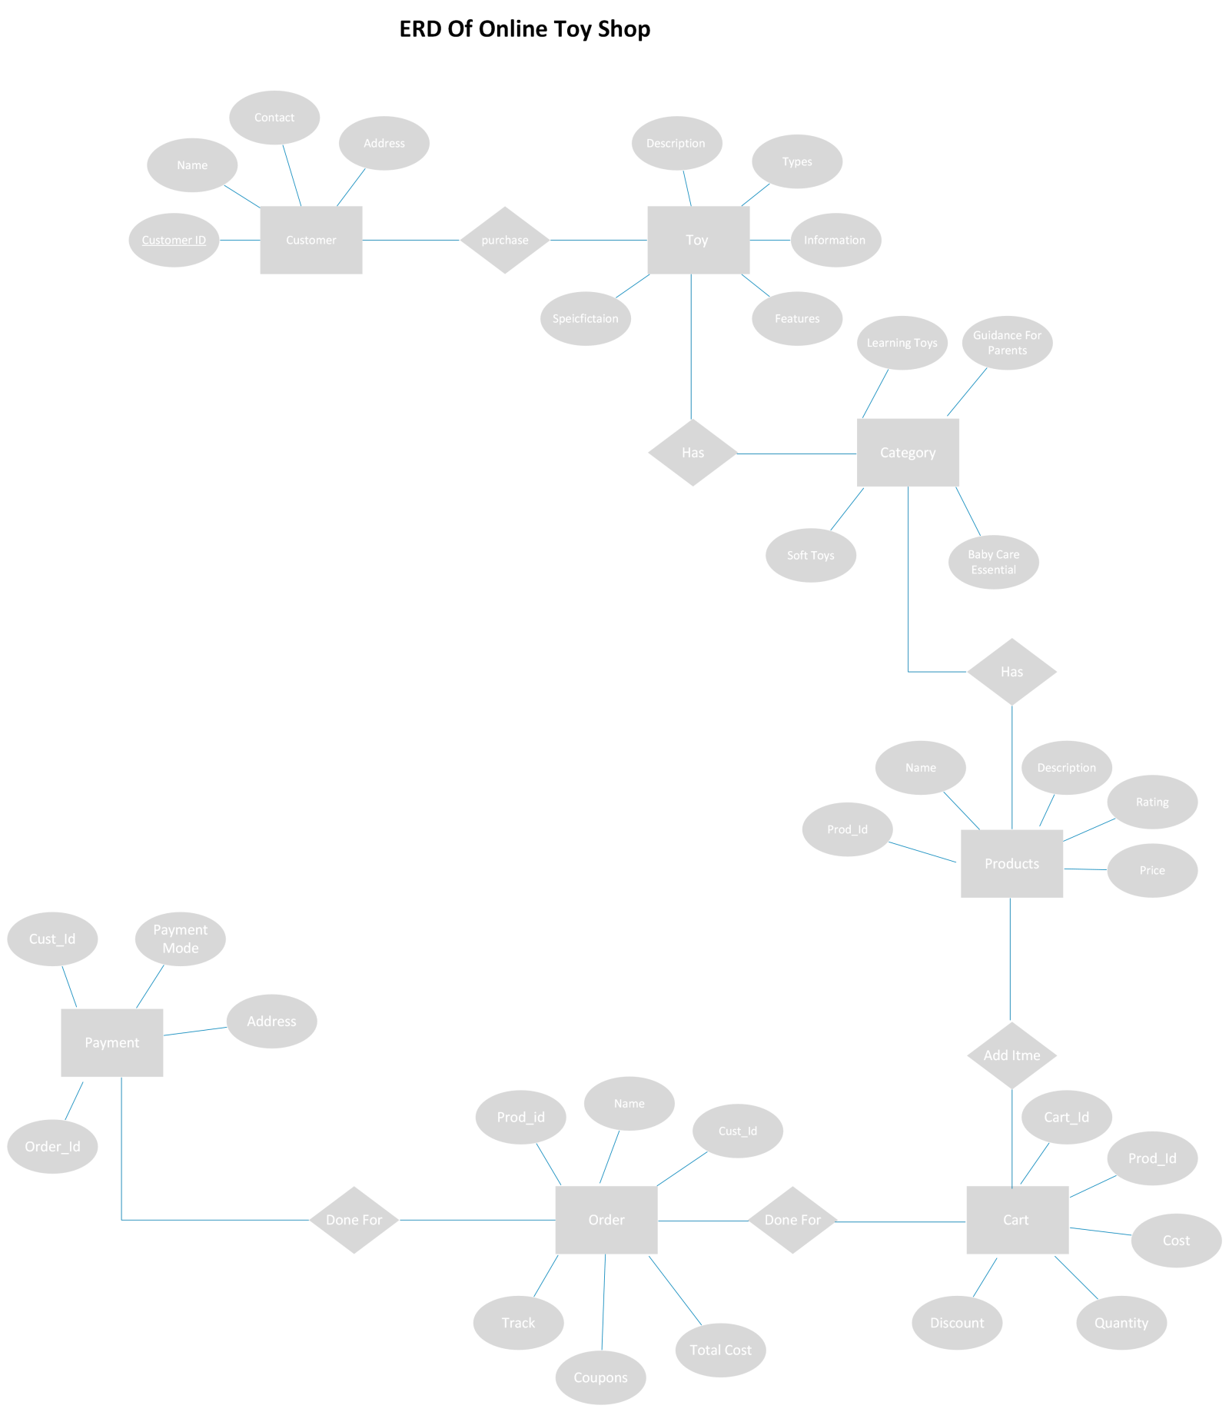

Class Diagram for Online Toy Shop

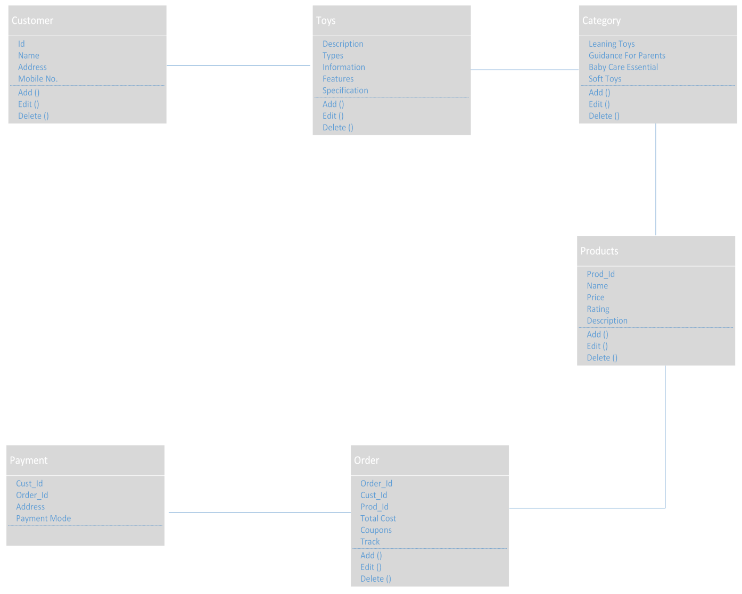

Sequence Diagram for Order Replacement/Refund

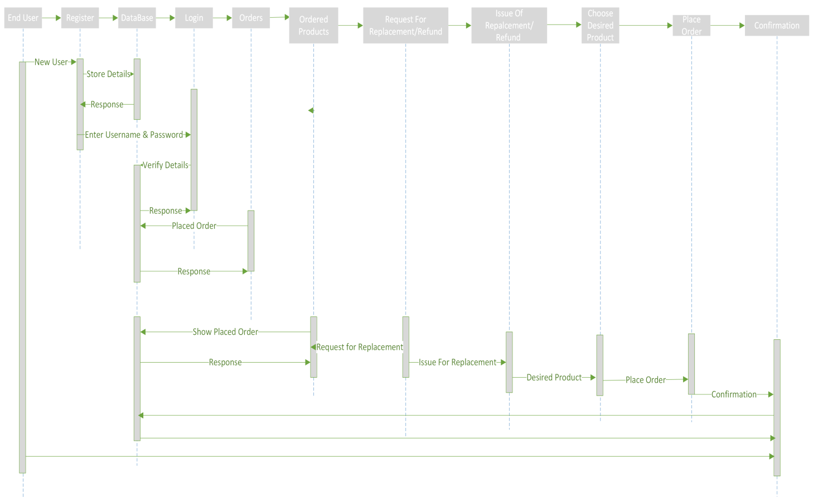

Data Flow Diagram for Movie Ticket Booking

